1. **Add 3 numbers**

**Program:**

# Add 3 numbers

num1, num2, num3 = input("Enter 3 numbers: ").split()

sum = int(num1) + int(num2) + int(num3)

print("Sum of the numbers is: ", sum)

**Output:**



1. **To Swap 2 numbers**

**Program:**

# To swap 2 numbers

num1 = int(input("Enter value to be stored in num1: "))

num2 = int(input("Enter value to be stored in num2: "))

temp = num1

num1 = num2

num2 = temp

print("After Swapping: num1 = ", num1, ", num2 = ", num2)

**Output:**

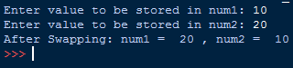

1. **Calculate area of triangle given 3 sides of triangle**

**Program:**

# Calculate area of triangle given 3 sides of triangle

import math

side1 = int(input("Enter 1st sides of the triangle: "))

side2 = int(input("Enter 2nd sides of the triangle: "))

side3 = int(input("Enter 3rd sides of the triangle: "))

p = (side1 + side2 + side3)//2

ans = math.sqrt(p*(p-side1)*(p-side2)*(p-side3))

print(ans)

**Output:**

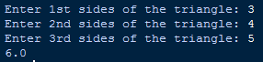

1. **To find roots of quadratic equation**

**Program:**

# To find roots of quadratic equation

import math

print("Let the equation be Ax^2 + Bx + C\n")

A = int(input("Enter value of A: "))

B = int(input("Enter value of B: "))

C = int(input("Enter value of C: "))

D = (B*B)-(4*A*C)

if(D<0):

print("Imaginary Roots")

elif(D==0):

print(-B/2*A)

else:

print(((-B)+math.sqrt(D))/2*A,((-B)-math.sqrt(D))/2*A)

`**Output:**

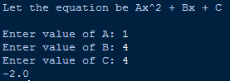

**5. To generate a random number between 0 and 100**

**Program:**

# To Generate a random number between 0 and 100

import random

repeat = True

while repeat:

print("Random number between 0 and 100: ", random.randrange(0,100))

repeat = input("Do you want to repeat ('Y','N'): ")

if repeat in ['y', 'Y', 'yes', 'Yes', 'YES']:

continue

else:

repeat = False

**Output:**

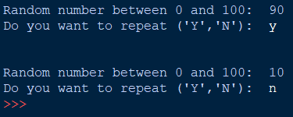

**6. To use bitwise operator**

**Program:**

# To use bitwise operator

a, b = 2, 3

print("Bitwise AND: a & b = ", a & b)

print("Bitwise OR: a | b = ", a | b)

print("Bitwise NOT: ~a = ",~a, ", ~b = ", ~b)

print("Bitwise XOR: a ^ b = ", a ^ b)

print("Bitwise right shift: a >> 1 = ",a >> 1)

print("Bitwise left shift: b << 1 = ",b << 1)

**Output:**

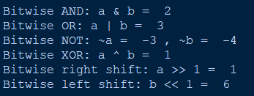

**7. To compute compound interest given all the required values.**

**Program:**

# To compute compound interest given all the required values.

principal = int(input("Enter Principal: "))

roi = int(input("Enter Rate of Interest: "))

compounder = int(input("Enter No. of times interest compounded in a year: "))

time = int(input("Enter Time(in years): "))

roi = float(roi / 100)

amount = principal*((1 + (roi/compounder))**(compounder*time))

print("The total amount after applying compound interest will be ", amount)

**Output:**

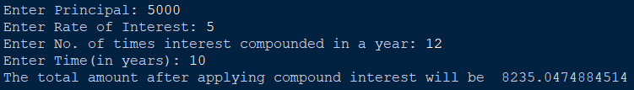

**8. To display calendar for the January 2019**

**Program:**

# To display calendar for the January 2019

import calendar

print("<--Calendar of January 2019--->\n")

print(calendar.month(2019,1))

**Output:**

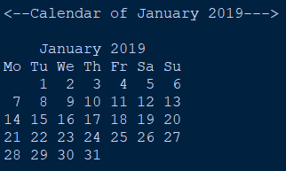

**9. To add two binary numbers**

**Program:**

# To add two binary numbers

num1 = input("Enter a number in Binary form: ")

num2 = input("Enter another number in Binary form: ")

add = bin(int(num1,2) + int(num2,2))

print("Value after adding the binary numbers: ", add)

**Output:**

